Math equation could help find missing Malaysian plane
Secondary Source: http://america.aljazeera.com/articles/2014/3/12/mathematical-equationcouldhelpfindmissingmalaysianplane.html
Primary source: http://mathtuition88.com/2014/03/13/math-equation-missing-plane/
Bayes’ Theorem helped researchers locate Air France Flight 447′s black box in 2011
(Video: How Bayesian Search found the USS Scorpion)
Days after a Malaysian airliner with 239 people aboard went missing en route to Beijing, searchers are still struggling to find any confirmed sign of the plane. Authorities have acknowledged that they didn’t even know what direction it was heading when it disappeared.
As frustrations mount over the failures of the latest technology in the hunt for Malaysia Airlines Flight MH370, some scientists say an 18th-century mathematical equation – used in a previous search for an Air France jetliner’s black box recorder – could help pinpoint the location of the Malaysian plane.
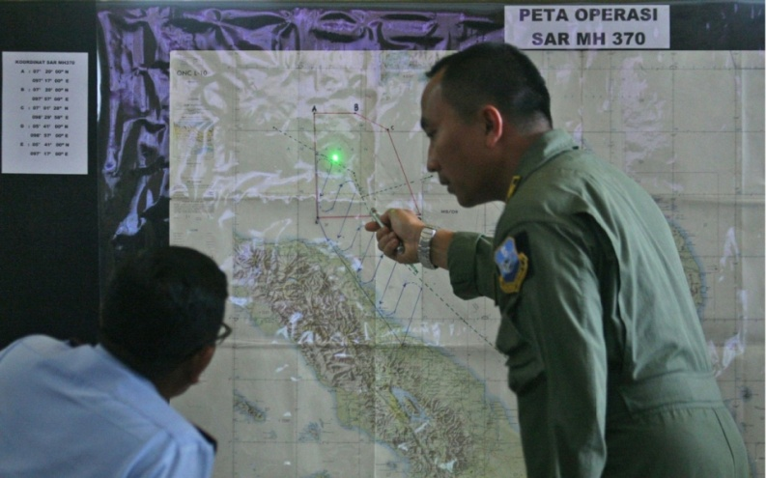
Indonesian Air Force officers examine a map of the Malacca Strait during a briefing following a search operation for the missing Malaysia Airlines Boeing 777, at Suwondo air base in North Sumatra, Indonesia, on Wednesday.AP2014
In 2009, Air France Flight 447 en route to Paris from Rio de Janeiro vanished over the Atlantic Ocean, triggering the most expensive and exhaustive search effort ever conducted for a plane. After two years, officials could only narrow the location of the plane’s black box down to an area the size of Switzerland.
But Flight 447’s black box was found in just five days after authorities contacted scientific consultants who applied a centuries-old equation called Bayes’ Theorem.
Read more at: http://america.aljazeera.com/articles/2014/3/12/mathematical-equationcouldhelpfindmissingmalaysianplane.html

What is Bayes’ Theorem
Mathematically, Bayes’ theorem gives the relationship between the probabilities of A and B, P(A) and P(B), and the conditional probabilities of A given B and B given A, P(A|B) and P(B|A). In its most common form, it is: (Wikipedia)
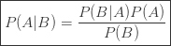
(Check out this post on probability formulas to learn more about Probability)

Proof of Bayes’ theorem (Theorem useful for finding MH370 plane)
The proof of Bayes’ theorem is actually relatively simple, the only requirement is to know the formula for conditional probability (Learnt in H1/H2 Maths): 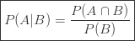
From this, we have
Similarly,
But since , we have . Dividing throughout by gives Bayes’ Formula:
Sincerely wishing that the MH370 plane will be found soon, and hopefully the passengers are still alive.
Also see: Bayesian search theory (Bayesian search theory is the application of Bayesian statistics to the search for lost objects. It has been used several times to find lost sea vessels, for example the USS Scorpion. It also played a key role in the recovery of the flight recorders in the Air France Flight 447 disaster of 2009.)
**************************************

Routine Data Analysis Helped Inmarsat Pinpoint MH370's Path
By Sean Broderick sean.broderick@aviationweek.com
Source: AWIN First
March 24, 2014
http://www.aviationweek.com/Article/PrintArticle.aspx?id=/article-xml/awx_03_24_2014_p0-674902.xml&p=1&printView=true
Inmarsat leveraged a “groundbreaking but traditional mathematics-based process” to analyze data from other flights that use its satellite network and establish a pattern that helped investigators nail down Malaysia Airlines Flight 370’s (MH370) final flight path as traveling south over the Indian Ocean, an Inmarsat executive explains.
Inmarsat’s initial analysis, handed over to investigators on March 11, helped investigators establish the now-famous northern and southern arcs as possible flight corridors for MH370 after it dropped off radar on March 8 over the Andaman Sea.
Inmarsat VP External Communications Chris McLaughlin says the company continued to analyze its data, and concluded on March 23 that the aircraft’s last known position was in the middle of the Indian Ocean, well southwest of Perth.
“What we discovered and what we passed to the investigation ... is that the southern path predicted fits very well with the path that’s been indicated by our pings,” McLaughlin says. “To all intents and purposes, there’s no way [the aircraft] went north.”
A key calculation done by Inmarsat was determining the “Doppler shift” in the ping, or the slight change in the frequency of the signal caused by the movement of the aircraft relative to the satellite in space.
“From that process – a compression or an expansion of the wavelengths – you can determine whether the aircraft is getting closer or farther away,” McLaughlin explains. “It’s been a groundbreaking but traditional mathematics-based process that was then peer-reviewed by others in the space industry, and indeed contributed to by Boeing.”
The data analyzed was generated by pings from MH370 to one of Inmarsat’s 10 satellites. McLaughlin likened the Inmarsat avionics and antenna on an aircraft to a mobile phone, while the applications that use the satcom link, including the Aircraft Communications and Reporting System (ACARS), are “apps.” On MH370, “the apps were turned off, but the handset wasn’t,” he explains.
Since MH370 was not sending routine communications, the Inmarsat satellite was sending hourly “polling signals” to the Boeing 777. So long as the aircraft was operating, acknowledgement signals came back. “This includes its unique identification code, and confirmation the aircraft satcom is still operating and available for communications, if required,” Inmarsat explains on its website.
Inmarsat used these signals to establish that MH370 was in the air for about 6 hr. after it lost contact. The deeper analysis helped the company and U.K. Air Accidents Investigation Branch investigators narrow down the final ping to a remote area over the southern Indian Ocean, in the vicinity of where search teams have been working for more than a week.
So far, sightings of debris have not been linked to MH370’s disappearance. However, the more detailed analysis was enough to convince Malaysian officials that the aircraft went down in the area where the recent search efforts has been focused.
“Based on the new analysis, Inmarsat and AAIB have concluded that MH370 flew along the southern corridor, and that its last position was in the middle of the southern Indian Ocean, west of Perth,” Malaysian Prime Minister Najib Razak said March 24.
The location is both “remote” and “far from any possible landing sites,” he continued. “It is therefore with deep sadness and regret that I must inform you that flight MH370 ended in the southern Indian Ocean.”

<img src="http://pentonmedia.122.2o7.net/b/ss/pentonaviationweek/1/H.26.1--NS/0" height="1" width="1" border="0" alt="" /> <img id="dnn_ctr6838_WebTrendsView_imgTracker" src="http://statse.webtrendslive.com//dcsxebuzh000008qh57odylrf_5t6w/dcs.gif?dcsdat=123456789123&amp;#38;dcsuri=%2fDefault.aspx&amp;#38;WT.ti=Article&amp;#38;WT.cg_n=%5bwebtrendsgroupname%5d&amp;#38;WT.cg_s=print+article&amp;#38;dcssip=www.aviationweek.com" />
Copyright © 2014, Penton
All rights reserved. Terms of Use | Privacy Policy

*****************************************

How 'groundbreaking' number crunching found path of Flight 370
By Thom Patterson, CNN
updated 2:03 PM EDT, Mon March 24, 2014
http://www.cnn.com/2014/03/24/world/asia/malaysia-airlines-satellite-tracking/index.html?hpt=hp_t1

(CNN) -- Monday's announcement by Malaysia's Prime Minister acknowledging that missing Flight 370 ended in the southern Indian Ocean opens the door to a big question: How did new number crunching confirm the Boeing 777's path?
Now we know for sure "there's no way it went north," said Inmarsat Senior Vice President Chris McLaughlin.
Malaysian Prime Minister Najib Razak said Monday that the plane was last tracked over the middle of the Indian Ocean, west of Perth, Australia. Malaysian Airlines has informed passengers' relatives that "all lives are lost," a relative told CNN.
Monday's announcement brings new questions about the mystery that has captivated the planet for more than two weeks. It also provoked a call that all airliners be constantly tracked.
The mathematics-based process used by Inmarsat and the UK's Air Accidents Investigation Branch (AAIB) to reveal the definitive path was described by McLaughlin as "groundbreaking."
"We've done something new," he said.
Here's how the process works in a nutshell: Inmarsat officials and engineers were able to determine whether the plane was flying away or toward the satellite's location by expansion or compression of the satellite's signal.
What does expansion or compression mean? You may have heard about something called the Doppler effect.
"If you sit at a train station and you listen to the train whistle -- the pitch of the whistle changes as it moves past. That's exactly what we have," explained CNN Meteorologist Chad Myers, who has studied Doppler technology. "It's the Doppler effect that they're using on this ping or handshake back from the airplane. They know by nanoseconds whether that signal was compressed a little -- or expanded -- by whether the plane was moving closer or away from 64.5 degrees -- which is the latitude of the orbiting satellite."
Each ping was analyzed for its direction of travel, Myers said. The new calculations, McLaughlin said, underwent a peer review process with space agency experts and contributions by Boeing.
It's possible to use this analysis to determine more specifically the area where the plane went down, Myers said. "Using trigonometry, engineers are capable of finding angles of flight."
What could wreckage tell us about Flight 370's fate?
No surprise
Experts said they weren't surprised by the news that the flight traveled along the southern track -- one of two possible paths revealed by satellite data last week. The possible northern track toward Pakistan would have been heavily monitored by radar. Pakistan had said it found no evidence of Flight 370 on its radar systems.
"It was very difficult to believe that no watch captain" along the possible northern path "would've seen a burning or distressed aircraft in the sky during the course of their watch," said McLaughlin.
Is the more pinpointed flight path now focused enough to increase the chances of finding wreckage from the plane?
If the flight definitely ended far from land, does that support the theory that the plane was not hijacked? It's just one question of many that investigators likely will be pondering in the coming days.
Hours before the Prime Minister's announcement, Australian officials said they had spotted two objects in the southern Indian Ocean that could be related to the flight, which has been missing since March 8.
One object is "a gray or green circular object," and the other is "an orange rectangular object," the Australian Maritime Safety Authority said.
"This is obviously a major tragedy," McLaughlin said. "The only thing you can hope is that from this, just as the Titanic resulted in (new safety legislation), that from this, there will be a mandate that all aircraft should be constantly tracked."
'They have told us all lives are lost'

****************************

