Maximum / Minimum Problems for Review

By David Pleacher

Solve each of the problems below. Find the correct answer from the choices below.

Then place the corresponding word in the appropriate blank to answer the two stupid questions.

_____ 1. Determine the constant a in order that the function y = x2 + a/x will have a point of

inflection at x = 1.

_____ 2. Determine the volume of the largest right circular cylinder that can be inscribed in a

given right circular cone with radius 3 inches and height 9 inches. (Answer is in cubic inches)

_____ 3. Determine the minimum point(s) of y = (x+2)2.

_____ 4. Where does the graph of y = (x-1)3 have a point of inflection?

_____ 5. Graph y = 2x4 - 4x2.

_____ 6. Sketch a smooth curve y = f(x) illustrating

f(3) = 4 f''(x) < 0 for x < 3

f'(3) = 0 f''(x) > 0 for x > 3

_____ 7. Determine the constant k in order that function f(x) = x2 + k/x will have a relative

minimum at x = 2.

________________________________________________________________________

Answers:

AT (-2, 0)

BE (4, 0)

COMPOSING 9π

DECOMPOSING 12π

EXTRA -54

LARGE (1, 0)

Answers (continued):

MEDIUM 16

IS -1

FORTUNETELLER 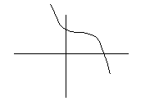

MIDGET 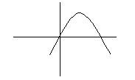

SMALL 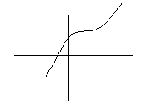

HE 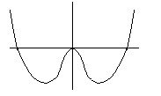

STILL 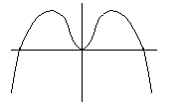

Question #1

What were the headlines after a midget fortuneteller escaped from jail?

Answer: __________ __________ __________ __________

#6 #7 #3 #4

Question #2

Why does Beethoven now spend all his time erasing music?

Answer: __________ __________ __________

#5 #1 #2