**Parabella**

adapted from a letter to the January 1985 *Mathematics Teacher*

by Alfinio Flores, Guanajuato, Mexico

###### Instructions: Replace each of the dashes below with a letter so that it makes a math word and completes the story.

Mother Q-------- was very happy with her new daughter, Parabella. The doctor was happy, too. He had feared a d--------- case, but fortunately Parabella was a r---- and healthy child. "She is   
beautiful, " said Mother Q--------. But what daughter is not beautiful in her mother's eyes? Parabella's elder sisters, Hyp and Elli, thought otherwise.

"Look how ugly she is. She has only one a--- of s-------," Hyp exclaimed. (see figure 1a) "She has only one f----," Elli added. "She certainly is not like us!" (figures 1b,c)

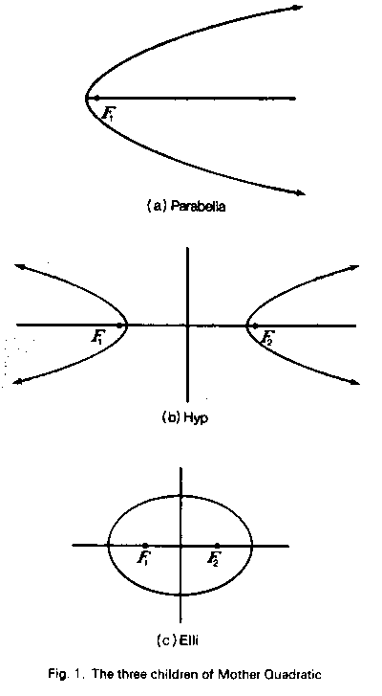

When Elli and Hyp wore their C-------- dresses, everybody could tell they were sisters:

parbel1d.gif

But Parabella looked different: y2 = 4px.

Parabella was bright, and soon discovered that her t-- sisters had other s-----------. With Elli, the s-- of the d-------- from each p---- to the foci was constant: dl + d2 = c (figure 2).

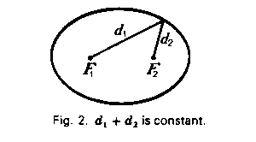

For Hyp it was the d--------- of the d-------- that was constant: dl - d2 = c (see figure 3).

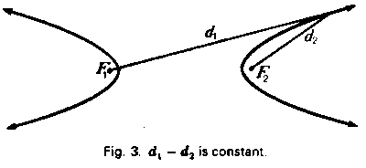

Parabella was sad because she could not find a similar p------- in herself. She only had one f----. 0-- day, when playing with a l---, she made an amazing discovery. If she put the line   
p------------ to her a---, so that her vertex was the same d------- from the line as it was from her

f---- (see figure 4), the same would be true for all her p----- (see figure 5)!

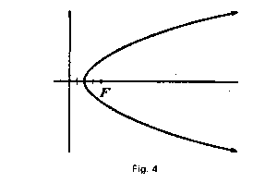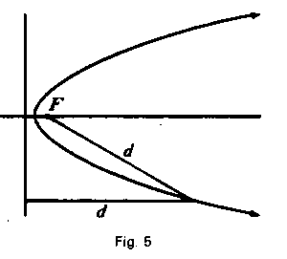

Parabella ran to tell her sisters the news. "Look, with my friend d-------- I have a property similar to yours!" The two elder sisters responded coldly, "Who needs a stupid l---?   
We don't need anything but our two f---."

Parabella was a little hurt. She wanted so much to convince her sisters that she was like them! The next day Parabella discovered that she could look at very distant objects. She was able to do this because she could concentrate p------- rays in her f---- (see figure 6). She had observed that Elli had a similar ability: Elli could concentrate the r--- emitted from one f---- in the other focus after reflecting them (see figure 7).

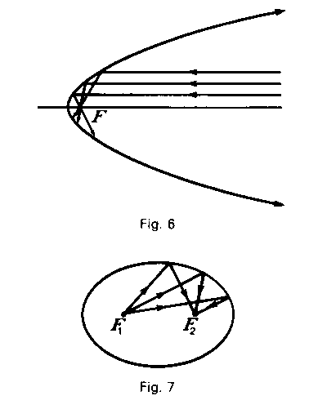

This time, however, Parabella did not tell her sister about her discovery. Parabella also discovered that this property of how the r--- were reflected enabled her to remember how to get a t------ line, which she always forgot (see figure 8). The same was true for Elli (see figure 9).

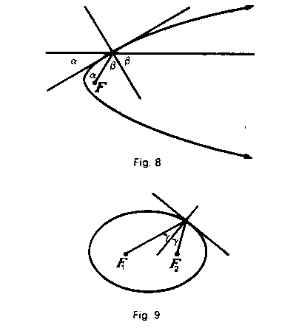

In the afternoon, Parabella read the book that her friend, the h------, had given her. It related the strange adventures of her friend's grandfather, a s-----. In the evening, Parabella ate lots of s------ of pie and ice cream.

She went to sleep and had a weird dream.

*Parabella's dream*

Parabella and her sisters were prisoners in Dandelin's castle.   
It was like a double ice cream Cone (see figure 10).

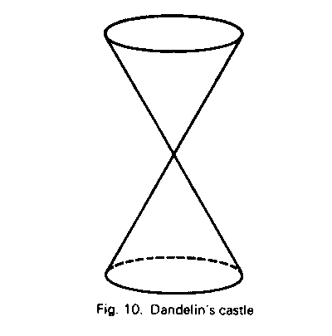

The castle was guarded by Dandelin's s------. Parabella could hear her sisters, but she knew they were not in the same p---- because the voices seemed to come from everywhere. 0-- of   
the spheres was holding her at the f----. Two s------ held Elli tight (see figure 11), and t-- more held Hyp. Parabella managed to escape by slicing the c--- with a p----. Another slice freed  
Elli, and Soon Hyp was free also (see figure 12).

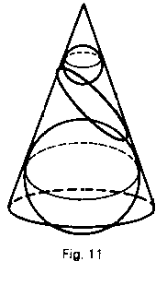 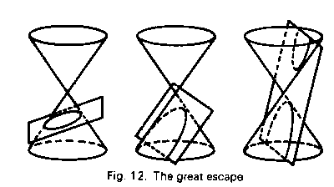

Parabella woke up very excited. She realized that she was more like her sisters than she thought. They were all c---- sections. In one sense, she was between her sisters. The  
slice that set Parabella free was between the slice that freed Elli and the o-- that freed Hyp.

She ran to tell her sisters the dream. But as soon as she started to describe the castle, that c--- in the third d--------, her sisters laughed at her. "That is what you get for eating so much at night and reading nonsense like Flatland."

This time Parabella was very upset: "You and your p----- thinking!" she cried and broke into tears. While she was weeping, the P---- Fairy appeared. "Do not cry, Parabella. I will get you some polar clothes and you will look like your sisters. You will also see that you are between them, as in your dream. I will even get a d-------- for everyone."

The P---- Fairy did what she promised, and soon the t-- sisters were dressed in their p---- clothes (see figure 15). The only difference among them was that

for Elli: e < 1

for Parabella: e = 1

for Hyp e > 1

The elder sisters at last recognized that they all shared s------ characteristics. Parabella was glad, and she lived happily ever after.

