Cross Math

Place each digit from 1 through 9 in the empty squares of the grid so that the three rows across and the three rows down form correct arithmetic statements. All calculations (which involve only positive integers) should be performed using the correct order of operations. Parentheses have been added where needed.

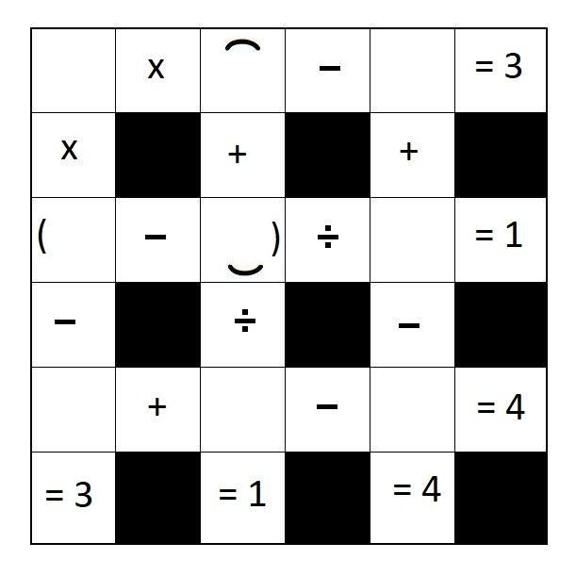

Answer available after June 2018 at:
www.pleacher.com/mp/probweek/p2018/a0618b.html

