Math Fill-Ins

A Puzzle by David Pleacher

Complete each crossword grid with words that fit the given category

(and in a few cases, some "generic" math words).

A word may be used in more than one category.

Category: Algebra

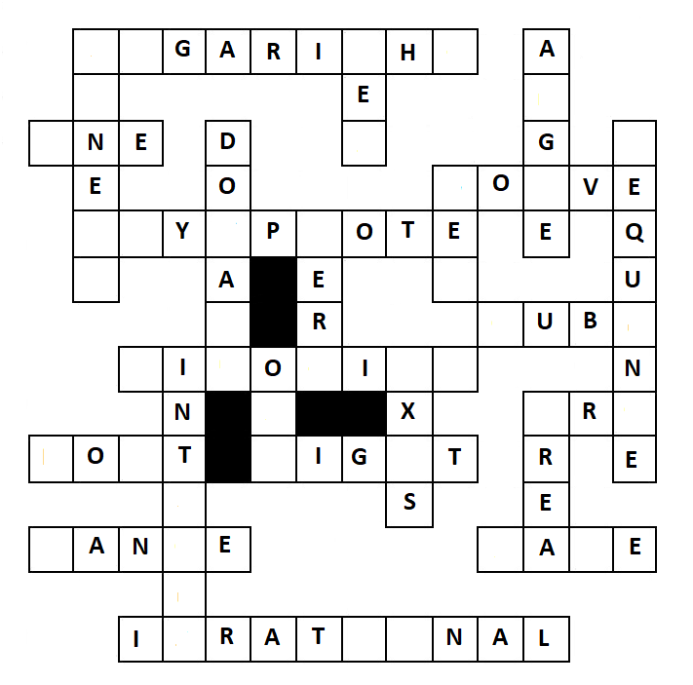

Category: Geometry

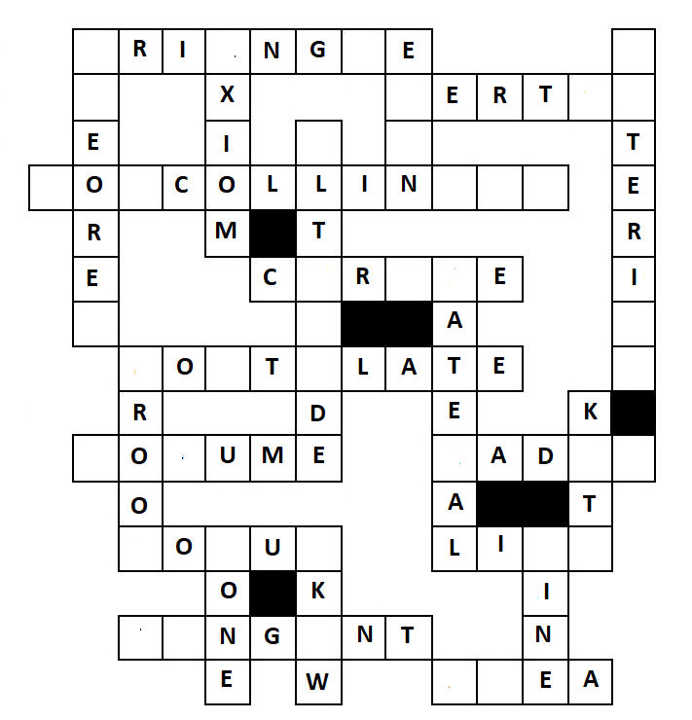

Category: Precalculus

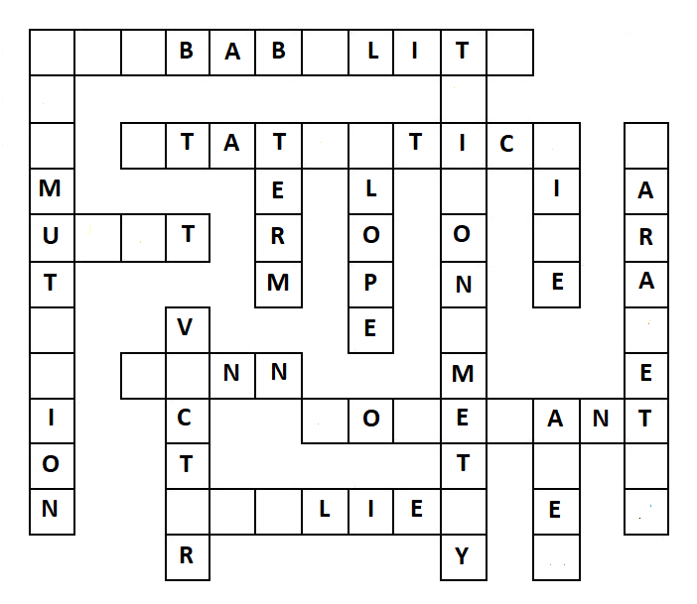

Category: Calculus

