An Equation Magic Square

A Puzzle by David Pleacher

Use what you've learned about solving equations to work the following problems.

Place each answer in the square with the problems.

If you've done your work correctly, you should get the same sum every time you add up a column, a row, or a diagonal.

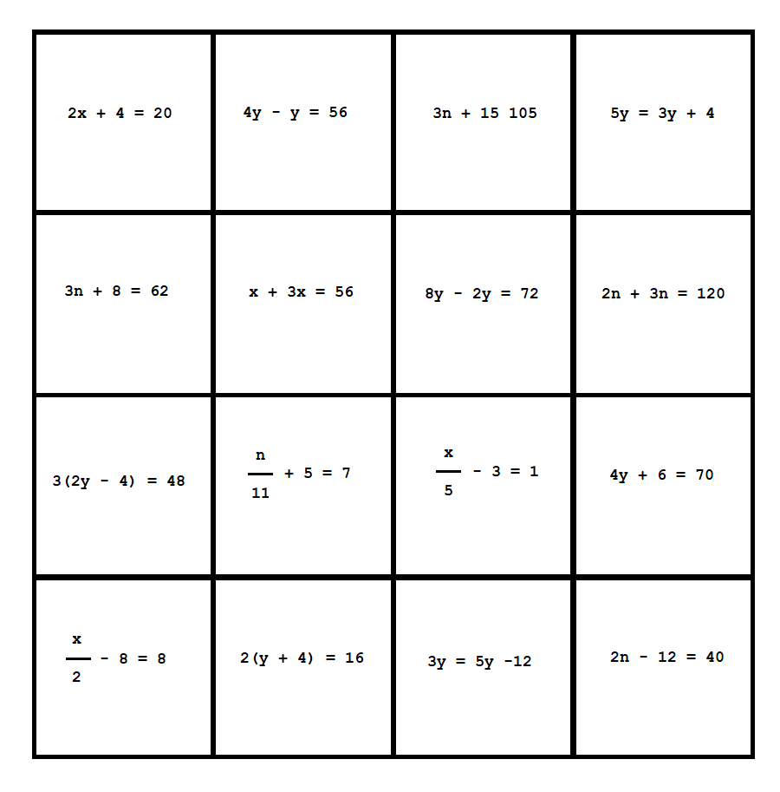

What is the sum of each column, row, and diagonal? _____________