Magic Square with Pictures

A Puzzle by David Pleacher

The object of a magic square is to arrange numbers within the cells of the square such that the horizontal rows, the vertical columns, and the two diagonals each add up to the same number called the magic number. In the magic square below, each image suggests a number.

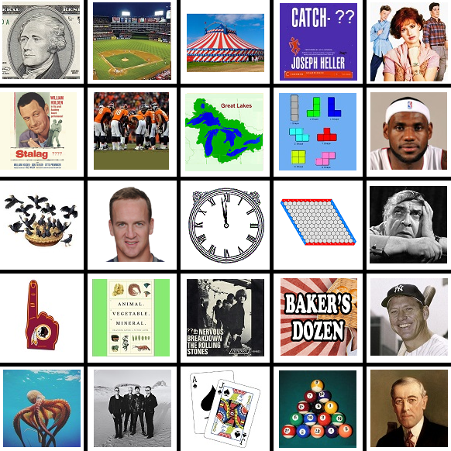

Magic Number = ______________

Can you solve the magic square?