Right Angles -- Calculus

A Puzzle by David Pleacher

Determine the answer to each problem on the next page.

Then write the word in the 10 by 10 matrix below using the following rules:

1. Each word makes one right-angle turn somewhere along its length. But you must determine

where each word makes this turn and in which direction.

2. As a guide, the starting direction (i.e., the direction of the word before its right angle turn) of

each answer is indicated by the letter given after the clue number.

3. Words can go North, South, East, or West to start with. For example, 1S begins on square 1

and heads South.

4. Each letter in the correctly completed grid appears in only one word.

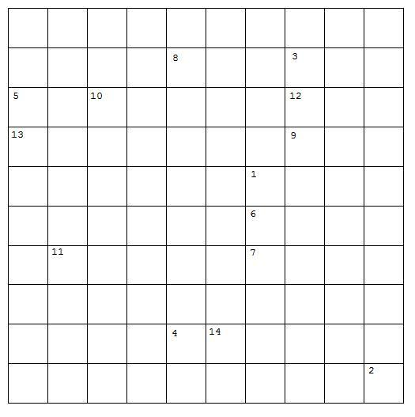

Calculus Problems:

1N The field of mathematics that deals with differentiation and integration is called

__________.

2W The _________ of a function exists if the right-hand limit and the left-hand limit both exist and are equal to each other.

3E The instantaneous rate of change of a function with respect to the variable is called the

__________.

4W The derivative of a __________ function is always a constant.

5N When a function can not be defined explicitly, it is best to use __________ differentiation.

6W The line perpendicular to the tangent line is called the __________.

7W The derivative of a function at a point is the slope of the __________ line at that point.

8W The points on a curve where the value is greater than that of the surrounding points is

called a relative __________.

9S The points on a curve where the value is less than that of the surrounding points is called a

relative __________.

10S A point on the curve where the concavity changes is called a Point of _________.

11N A function is __________ down if f''(x) < 0 .

12E (u v )' = uv' + vu' is called the __________ rule.

13S The derivative of sin(x) with respect to x is the _________ of x.

14S The set of all possible values of the argument of a function is called the __________.

Many thanks to Nacoe Thomas for finding the error in 11N. The third derivative should have been a second derivative and is now correct.