Geometric Shapes Search

A Puzzle by David Pleacher

Connect the letters to form word chains.

Connections can be made vertically, horizontally, or diagonally.

Diagonal connections are allowed to cross.

Every letter will be part of exactly one word.

There are thirteen words – all geometric shapes.

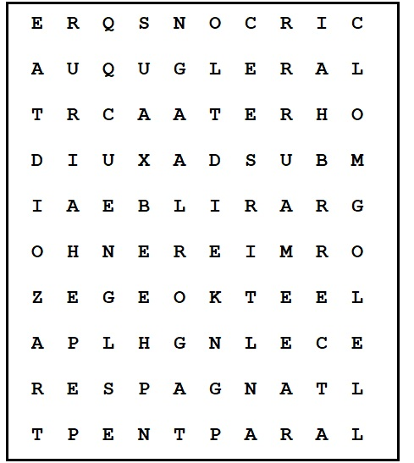

Hint: One word begins in the bottom left corner and another word begins in the upper right corner.