A Droodle for the S.A.T. Math Exam without a calculator

A puzzle by David Pleacher

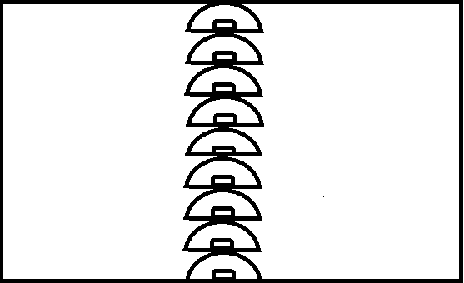

"A Droodle is a borkley looking sort of drawing that doesn't make

any sense until you know the correct title." – Roger Price

Caption for the picture:

__ __ __ __ __ __ __ __ __ __ __ __ __ __ __ __ __ __ __ __ .

20 13 12 1 9 18 16 8 7 17 4 11 14 5 2 19 3 15 6 10

To determine the title to this droodle, solve the 20 math problems which are similar to problems found on the S.A.T. math section.

Then find the answers to each problem from the choices listed.

Replace the numbered blank with the letter corresponding to the answer for that problem.

A calculator should not be used on this part of the exam.

___ 1. On Sunday afternoon, Jackson sent *m* text messages each hour for 5 hours, and Kate

sent *p* text messages each hour for 4 hours. Which of the following represents the total

number of messages sent by Jackson and Kate on Sunday afternoon?

A. 9*mp*

X. 20*mp*

I. 5*m* + 4*p*

S. 4*m* + 5*p*

___ 2. *g*(x) = *ax*2 + 24

For the function *g(x)*, *a* is a constant and *g*(4) = 8.

What is the value of *g*(-4) ?

P. -8

L. -1

O. 0

T. 8

___ 3. 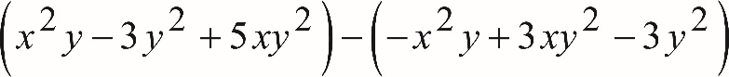

Which of the following is equivalent to the preceding expression?

K. 4*x*2*y*2

N. 8*xy*2 -6*y*2

O. 2*x*2*y* + 2*xy*2

T. 2*x*2*y* +8*xy*2 -6*y*2

___ 4. If  and , what is the value of *y*?

T. 10

E. 12

R. 14

M. 19

___ 5. 

What is the solution (x, y) of the system of equations?

U. (4, -6)

N. (3, -8)

I. (-5, -2)

T. (9, -6)

___ 6. Refer to the figure below:

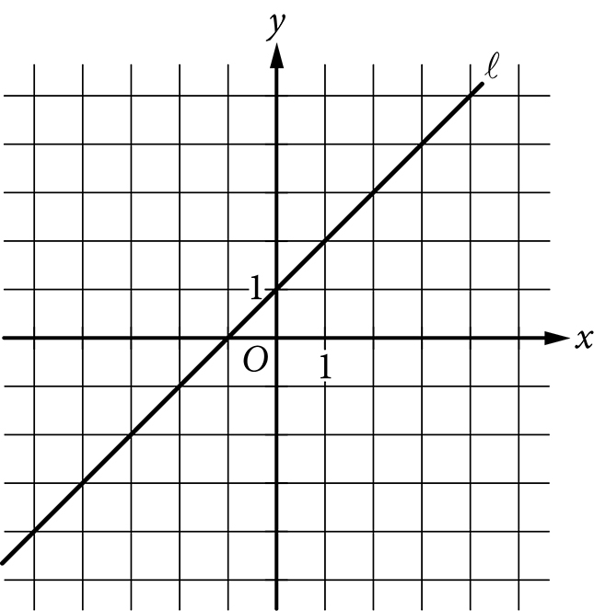

Which of the following is an equation of the line l ?

A. y = 1

R. y = x

C. y = x - 1

S. y = x + 1

___ 7. What are the solutions of the quadratic equation 4x2 – 8x = 12 ?

B. x = -1 and x = -3

A. x = -1 and x = 3

S. x = 1 and x = -3

E. x = 1 and x = 3

___ 8. Which of the following is an example of a function whose graph has no x intercepts?

M. A linear function whose rate of change is not zero

A. A quadratic function with real zeros

P. A quadratic function with no real zeros

S. A cubic polynomial with at least one real zero

___ 9. Refer to the figure below.

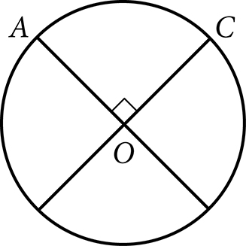

The circle above with center O has a circumference of 36. What is the length of minor arc  ?

M. 9

P. 12

E. 18

G. 36

___ 10. The volume of right circular cylinder A is 22 cubic centimeters.

What is the volume, in cubic centimeters, of a right circular cylinder

with twice the radius and half the height of cylinder A?

A. 11

M. 22

E. 44

N. 66

___ 11. The expression  where x >1 and y>1, is equivalent to which of

the following?

S. 

P. 

A. 

M. 

___ 12. Which of the following expressions is equivalent to  ?

D. 

I. 

S. 

K. 

___ 13. The expression  can be rewritten as , where *k* is a

positive constant. What is the value of *k* ?

L. 2

E. 6

G. 

S. 

___ 14. In the figure below,  and  intersect at point *P*, *NP* = *QP*, and

*MP* = *PR*. What is the measure, in degrees, of ?

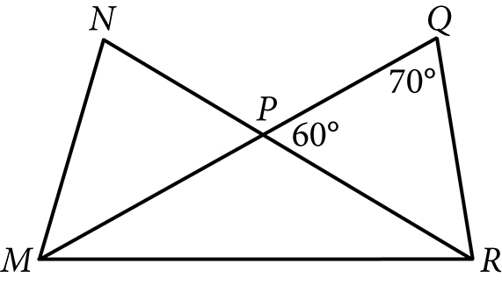

J. 20

E. 30

R. 40

K. 50

___ 15. The number of radians in a 720 degree angle can be written as ,

where *a* is a constant. What is the value of *a* ?

P. 2

L. 3.14

U. 4

S. 6

___ 16.

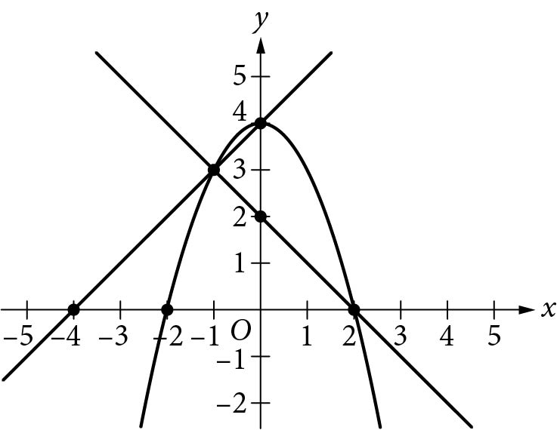

A system of three equations is graphed above in the x y plane.

How many solutions does the system have?

M. None

A. One

T. Two

H. Three

___ 17. Which of the following represents all the possible values of x that satisfy

the following equation?



T. 0 and 2

R. 0 and 4

I. -4 and 4

G. 4

___ 18. Given the expression  for x > 0, which of the following is an

equivalent expression?

Z. 

E. 

R. 

O. 

___ 19. The graph of the function f below is a parabola.

Which of the following defines f ?

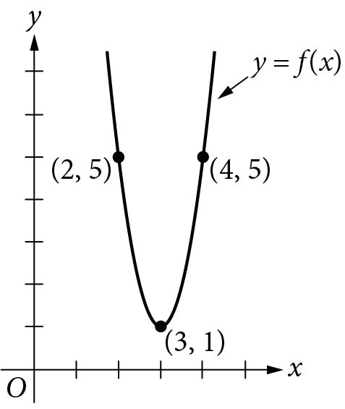

H. 

T. 

M. 

L. 

___ 20. The graph of the linear function *f* is shown in the following diagram.

The graph of the linear function *g* (not shown) is perpendicular to

the graph of *f* and passes through the point (1, 3).

What is the value of *g(0)* ?

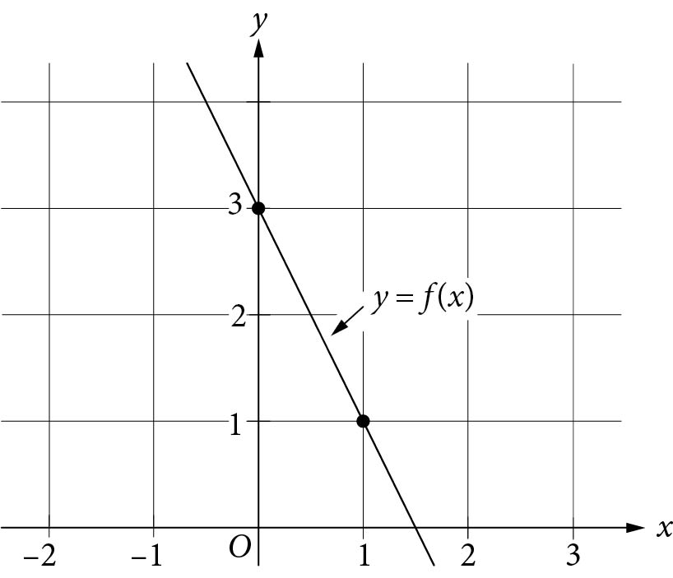

R. -5

A. -1.5

T. 2

E. 2.5

The droodle used in this puzzle was drawn by Roger Price and appeared in his book called *Droodles.*