A Droodle for the S.A.T. Math Exam without a calculator

A puzzle by David Pleacher

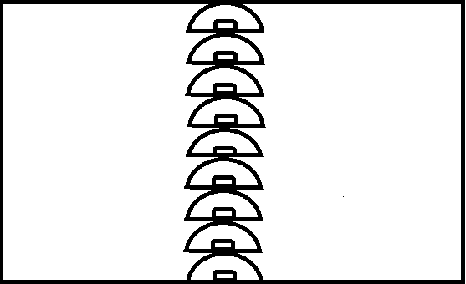

"A Droodle is a borkley looking sort of drawing that doesn't make

any sense until you know the correct title." – Roger Price

Caption for the picture:

**E S K I M O A P A R T M E N T H O U S E**

__ __ __ __ __ __ __ __ __ __ __ __ __ __ __ __ __ __ __ __ .

20 13 12 1 9 18 16 8 7 17 4 11 14 5 2 19 3 15 6 10

I 1. On Sunday afternoon, Jackson sent *m* text messages each hour for

5 hours, and Kate sent *p* text messages each hour for 4 hours. Which of the following represents the total number of messages sent by Jackson and Kate on Sunday afternoon?

Jackson sent *m* messages for 5 hours for a total of 5*m* messages

while Kate sent *p*  messages for 4 hours for a total of 4*p* messages.

So the answer is 5*m* + 4*p* messages.

T 2. *g*(x) = *ax*2 + 24

For the function *g(x)*, *a* is a constant and *g*(4) = 8.

What is the value of *g*(-4) ?

Substitute 4 for x in the original function:

*g*(4) = *a*(4)2 + 24 and set it equal to 8.

16*a* + 24 = 8. So a = -1.

Therefore, *g*(-4) = (-1)(-4)2 + 24 = -16 + 24 = 8.

_O_ 3. 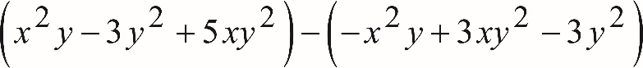

Which of the following is equivalent to the preceding expression?

Collect li *x*2*y* ke terms:

*x*2*y* + *x*2*y* - 3*y*2 + 3*y*2 + *5xy*2 - 3 *xy*2

2 *x*2*y* + *2xy*2

_T_ 4. If  and , what is the value of *y*?

Substitute 3 for h: 

Then multiply by 3: *y* – 1 = 9, so *y* = 10

_N_ 5. 

What is the solution (x, y) of the system of equations?

Multiply the top equation and 3, then subtract the bottom equation:



_S_ 6. Refer to the figure below:

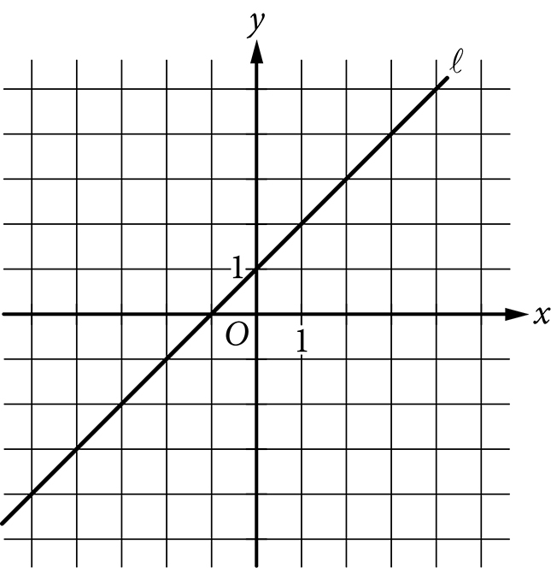

Which of the following is an equation of the line l ?

The slope is 1 and the y-intercept is 1, so the equation is

y = x + 1

_A_ 7. What are the solutions of the quadratic equation 4x2 – 8x = 12 ?

Divide each side by 4 to get x2 – 2x – 3 = 0

Factor to get (x – 3) (x + 1)

So, x = –1 and x = 3

_P_ 8. Which of the following is an example of a function whose graph has no x intercepts?

A quadratic function with no real zeros .

That means the function does not intersect the x-axis.

_M_ 9. Refer to the figure below.

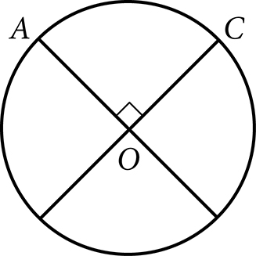

The circle above with center O has a circumference of 36. What is the length of minor arc  ?

The arc AC represents ¼ of the circle, so the length of the arc is ¼ of the

circumference = ¼ (36) = 9.

_E_ 10. The volume of right circular cylinder A is 22 cubic centimeters.

What is the volume, in cubic centimeters, of a right circular cylinder

with twice the radius and half the height of cylinder A?

The volume of a cylinder is given by the formula: .

Now take twice the radius and half the height to get: 

Simplify to get 

Since the new volume is twice as large as the original volume, the

new volume is 2 x 22 = 44 cubic centimeters.

_M_ 11. The expression  where x >1 and y>1, is equivalent to which

of the following?



_K_ 12. Which of the following expressions is equivalent to  ?

Divide using long division:



This is equivalent to 

_S_ 13. The expression  can be rewritten as , where *k* is a

positive constant. What is the value of *k* ?



So, *k* =

E 14. In the figure below,  and  intersect at point *P*, *NP* = *QP*, and

*MP* = *PR*. What is the measure, in degrees, of ?

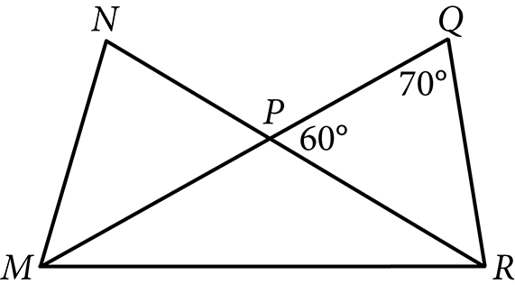

 since it is a supplement to 60 degrees.

Since *MP* = *PR*, that makes 

So, = 30 degrees.

_U_ 15. The number of radians in a 720 degree angle can be written as ,

where *a* is a constant. What is the value of *a* ?



_A_ 16.

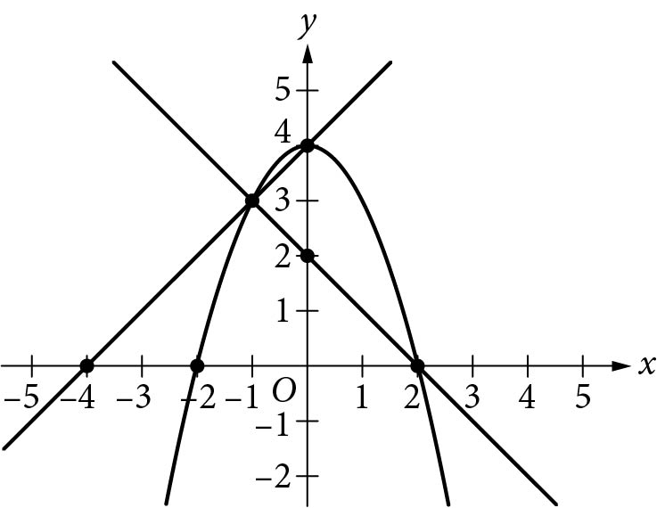

A system of three equations is graphed above in the x y plane.

How many solutions does the system have?

Just one point where all three equations intersect (-1, 3)

_R_ 17. Which of the following represents all the possible values of x that satisfy

the following equation?



Divide 5x by 5 to get *x*. The multiply each side by *x* – 3:



So, x = 0 and 4

_O_ 18. Given the expression  for x > 0, which of the following is an

equivalent expression?

= 

H 19. The graph of the function f below is a parabola.

Which of the following defines f ?

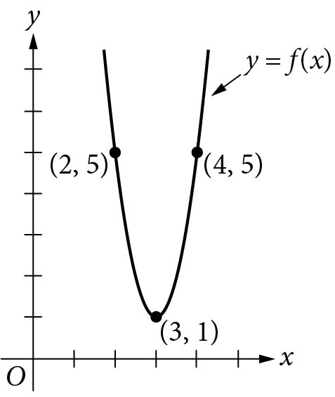

Answer is 

_E_ 20. The graph of the linear function *f* is shown in the following diagram.

The graph of the linear function *g* (not shown) is perpendicular to

the graph of *f* and passes through the point (1, 3).

What is the value of *g(0)* ?

